A tool for modeling and configuring matrix-based feature models

Authors Name/s per 1st Affiliation (Author)
line 1 (of Affiliation): dept. name of organization
line 2: name of organization, acronyms acceptable
line 3: City, Country
line 4: e-mail: name@xyz.com
Authors Name/s per 2nd Affiliation (Author)
line 1 (of Affiliation): dept. name of organization
line 2: name of organization, acronyms acceptable
line 3: City, Country
line 4: e-mail: name@xyz.com

Abstract—Feature-oriented analysis and modeling is a widely accepted software reuse method. It consists of two major activities that should be taken seriously. The first activity is to construct a feature model, and the second one is to configure products from the feature model. This paper introduces a new kind of feature model expressed in the form of matrices. Its main advantage is that it is scalable to very large feature models, comparing to traditional graphic-based feature models. A tool for constructing and configuring the kind of feature model is presented.
Keywords-feature model; matrix-based; configuration

Introduction
Feature models are widely adopted in domain-oriented software reuse. The reuse activity consists of two major steps. First a domain feature model is constructed to capture commonality and variability in a specific domain, in terms of features and constraints between features. Second, products of the domain are derived from the feature model by selecting a set of features without violating any constraints.
<接下来分别讲在建模和定制中存在的问题。这一段讲建模，主要是图形化的表示缺乏可扩展性>There are many forms to manifest a feature model. In most existing methods and tools, feature models are often represented graphically as a feature tree. However, whichever the expression used in the tool, representation between refinements and constraints must be balanced and the tool need to take into account the intuition, convenience and content integrity. However, the conventional tree structure will decrease its intuitive to ensure the content integrity when the number of constraints increasing, which surely impair the convenience. Meanwhile, the feature model users need to easily understand the relationship between the features and constraints to deal with configuration.
<这一段讲定制，主要是需要自动传播和重做，尤其是后者和复杂约束在一起之后很困难>The feature model customizer need to determine whether each of the optional features is bound in the application system. This action appears to be simple, only needs to be determined one by one on the the binding state of features. Since there are a large number of constraints and refinement relations in the feature model, it is necessary to take into account if the the binding state of feature is able to satisfy the refinements and constraints. Therefore, the tool needs to assist customizer by configurating action to ensure the action satisfying the refinements and constraints.
<这段合并到上一段，点出现有的工作没有解决定制中的上述问题即可>Previous studies for the customization of the feature model, more focused on the simple constraints in the feature model. The configuration about composite constraints is needed in the configuration tool. In addition, if the custom choose the wrong custom decision-making, the undo and selective-undo operation is be supplied. The efficiency and correctness are both the issues to be considered.
In this paper, we present a tool for modeling and configuring feature models. This tool provides a matrix-based expression to display feature model. It gives the algorithm of the auto-propagation of feature model configuration, and it can do the operation of selective-undo.
<最好给工具起一个名字，把名字放到题目和后文中>

Our work
We implement a tool for modeling and configuring matrix-based feature models. It is developed as a plugin for Eclipse 3.2 or later versions.

Modeling
Our tool aims at easy and scalable modeling for large feature models. The main user interface is shown in Fig. 1. Users can create a child or sibling for a selected feature, modify a feature or remove a feature. <这个地方应该仔细说明你是怎么表示约束关系的，毕竟这是主要的工作点，而且也和矩阵最相关> Optional features are shown in the light blue font in order to distinguish from the mandatory ones. The advantage of matrix-based expression is that the tree items can be collapsed so that users can hide some features which is not needed temporarily. The tool provides the function that user can hide part of the constraints. The tool also presents attributes of a feature in the bottom view.
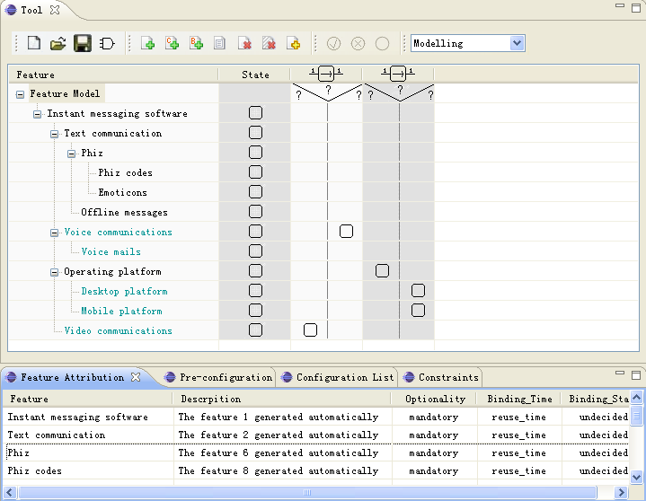
Figure 1. Modeling Mode

Configuration
Our tool provides automated support for configuration; that is, derive a product from a feature model. In the configuration, each feature in the feature model (except the mandatory root feature) may go into three states: bound (i.e. selected into the product), removed (i.e. eliminated from the product), and undecided. Since there are constraints between features, the change of a feature’s state may affect other features’ states. There are two kinds of situations: propagation and selective-undo.
<接下来一段说propagation>When user bind or remove a feature whose binding state is undecided, the bindind state of other features may be changed to bound or removed, and we call this process auto-propagation of configuration. If an undecided feature is related to a constraint whose the other predicate is known as true or false, the tool will remind customizer to bound or remove this feature.
<这一段说selective-undo>If user change the binding state from bound or removed to undecided, the tool will change the binding states of relative features to undecided to satisfy constraints. The process is called selective-undo. If the user change the binding state of a feature from bound or removed to another, the tool will execute the selective-undo operation firstly and then do the configuration.
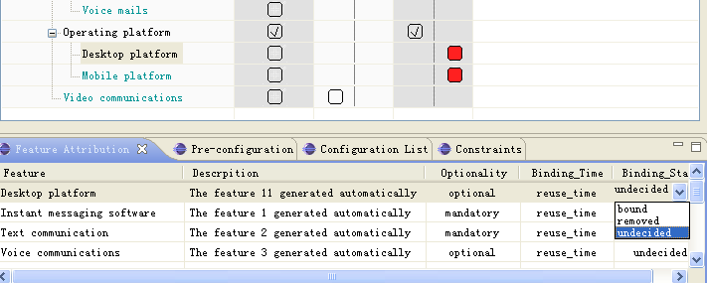
Figure 2. Configuration Mode

The tool provides the function to do the pre-configuration operation. The reason why a feature is bound or removed is shown in the view. It shows the features affected by the configuration operation.
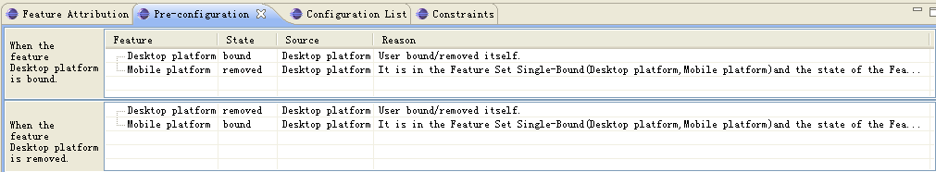
Figure 3. Pre-configuration View

The “Configuration List” view records what operations users have adopted. It just records the bind and remove operations. When users selective-undo a feature, the configuration list remove some items instead of adding a new operation.
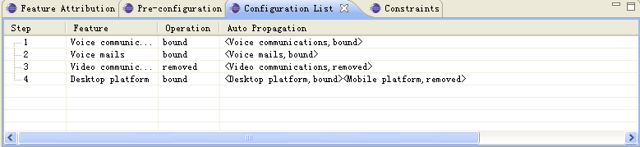
Figure 4. Configuration List

Other Function
This tool provides functions to convert a logical expression to feature models. Logical variables and their negatives are mapped to leaf features, while clauses of variables are mapped to branch features. The bound binding state means the expression is true, on the contrary, the removed state means false. The configuration and verification operation can be used in matrix-based feature model tool to analysis logical expressions. This function is displayed as the figure below.
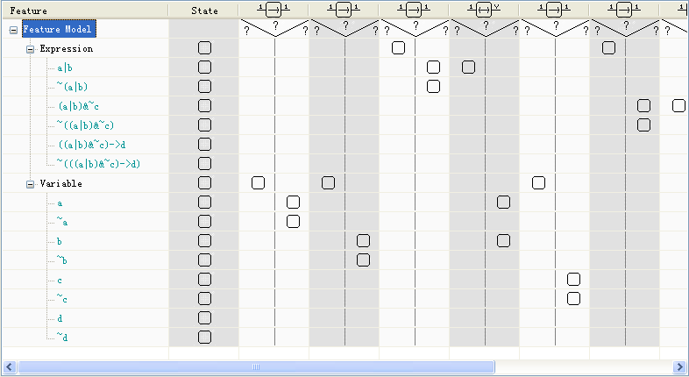
Figure 5. Logical Expression

Conclusion and future work
The matrix-based feature model tool uses the matrix-based expression to do the modeling and configuration for feature models. The tool shows the auto-propagation and selective-undo function. Future work includes providing the solutions to change the binding state of a feature from bound/removed to undecided(the selective-undo algorithm gives one solution) and other extension functions. The verification for a feature is also a promising function.

References

